News Listing Component

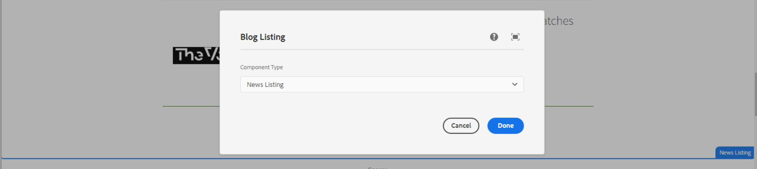

In this dropdown below list of component types are available, we can select one type as per our requirement.

1. **News Listing** - This component will use in News listing page.

**Page Reference** - <https://www.ancestry.com/corporate/newsroom/in-the-news>

**AEM URL** - <https://author-ancestry-dev2.adobecqms.net/content/ancestry-corp/us/en/newsroom/in-the-news.html?wcmmode=disabled>

In this component, below list of fields are visible

* **Year filter dropdown** – Able to find any news using year filter.
* **News listing section** – When we create a news using a new-content-fragment then that news will be shown here and also the list of news are visible.
* **Pagination** – Using pagination we can able to see all the news while clicking on the pagination number.

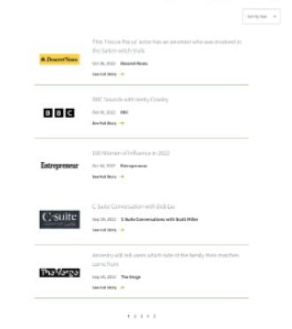

1. **Featured News (Homepage) -** This component will use in Homepage.

**Page Reference -** <https://www.ancestry.com/corporate/>

**AEM URL** - <https://author-ancestry-dev2.adobecqms.net/content/ancestry-corp/us/en.html?wcmmode=disabled>

We just need to author the left section (title and button) and the right section will be visible dynamically.

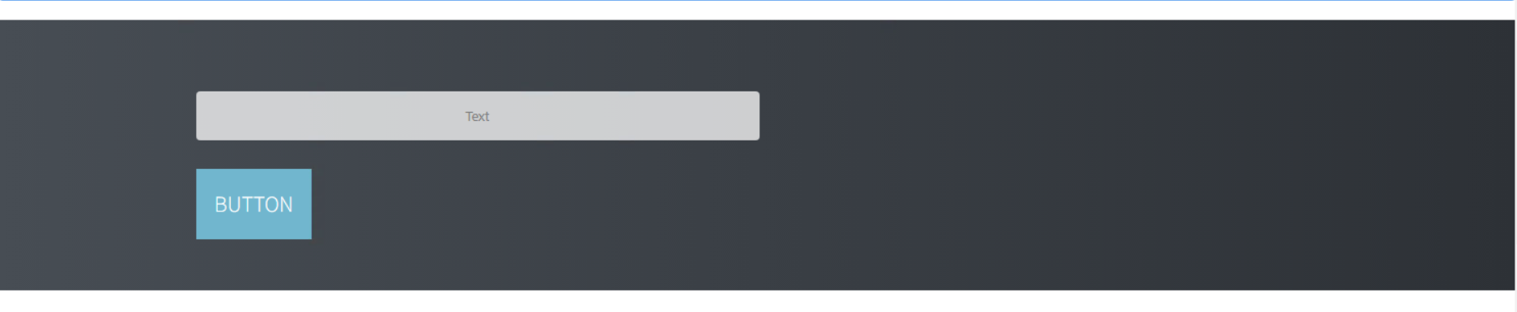

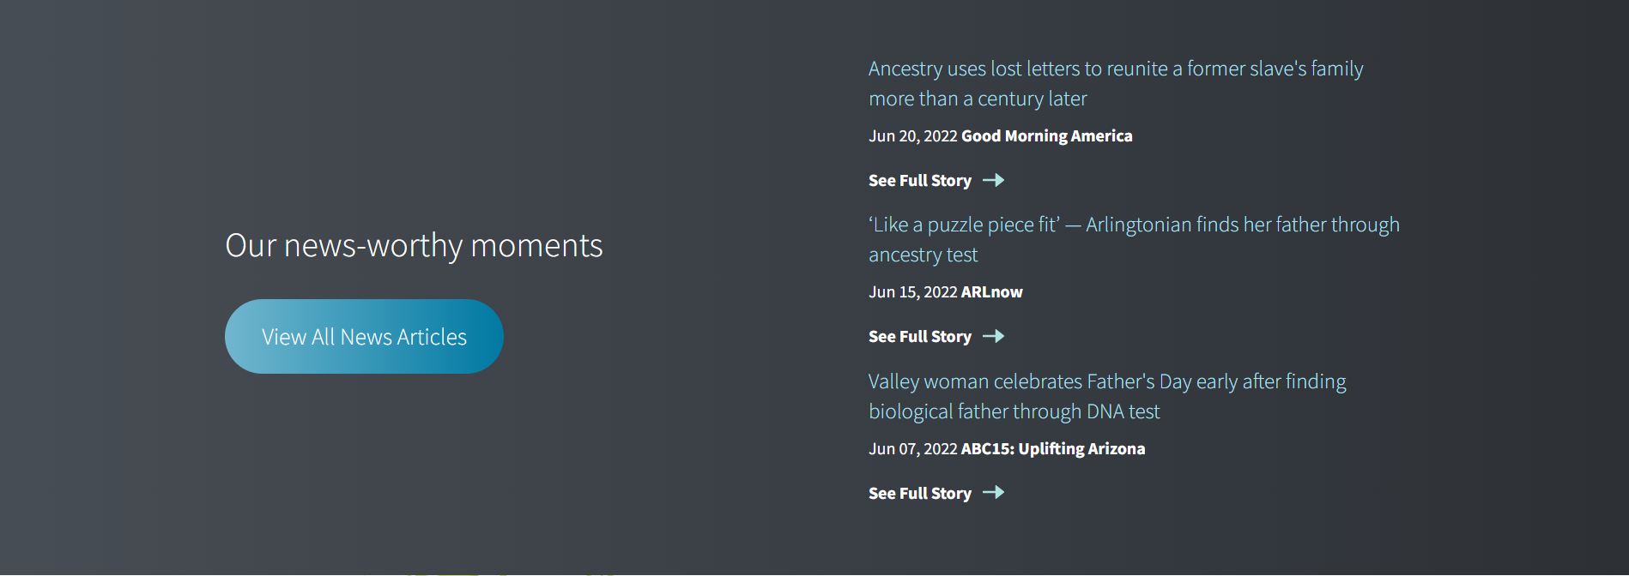

To display the right section, Go to the News content Fragment in asset.

<https://author-ancestry-dev2.adobecqms.net/assets.html/content/dam/ancestry-corp/News-Content-Fragments>

Open the news as per requirement and on the top of the page, there is an option to select the checkbox (display on Homepage) then that news will be displayed on the homepage. As per logic, the latest 3 (date-wise) news will be shown.

